23CSE202 DATABASE MANAGEMENT SYSTEMS
S3 B.Tech CSE
Department of Computer Science and Engineering
Amrita School of Computing, Amritapuri Campus

PROJECT REPORT

Group No : D6
Team Members :
Roll No | Student Name
AM.SC.U4CSE25343 | Vedananda
AM.SC.U4CSE25334 | Yaswanth
AM.SC.U4CSE25345 | Saket
AM.SC.U4CSE25337 | Swapnil

Project Title : FlavorFlow - Online Food Delivery System
CONTENTS
Sl. No | Chapter | Page No
1 | Abstract | 2
2 | Introduction | 3
3 | Requirements (Functional & Non-functional) | 4
4 | UI Design | 6
5 | Database Design | 12
6 | Database Selection & Justification | 16
7 | Implementation | 17
8 | Testing & Validation | 20
9 | Results & Screenshots | 23
10 | Challenges Faced & Solutions | 27
11 | Conclusion & Future Enhancements | 28
 | References | 29

1. Abstract
Online food ordering has become a daily habit, but many small restaurants and customers still depend on phone calls, paper menus and manual tracking, which leads to errors, delays and no record of past orders. This project, FlavorFlow, is a web-based Online Food Delivery System inspired by platforms such as Swiggy and Zomato. It lets a customer register, browse restaurants and menus, build a cart, check out with a saved delivery address, track the order through its stages and leave feedback after delivery. The system is built as a three-tier application: HTML, CSS and JavaScript pages on the front end, Java servlets running on Apache Tomcat 10.1 as the back end, and a PostgreSQL database. The database is designed in eleven relations, normalized up to Boyce-Codd Normal Form, and uses primary keys, foreign keys, unique and check constraints, and transactions to keep data consistent. Checkout is atomic, so an order, its items, its payment and the emptied cart are saved together or not at all. A dispatch routine moves orders through their stages and assigns free delivery agents. The result is a working prototype that covers the full ordering lifecycle and demonstrates how a relational database supports a real transactional application.

2. Introduction

2.1 Problem Domain and Background
Food delivery is a high-volume, time-sensitive business. A single order touches a customer, a restaurant, a menu, a payment and a delivery agent, and each of these must stay consistent with the others. Customers expect to see what is available, what they have chosen, what it costs and where their food is. Restaurants need accurate orders and a way to receive them. Delivery agents need to know which orders they are carrying.

2.2 Existing Scenario and Its Limitations
In many local settings, ordering still happens by phone or by walking into a restaurant. Menus are printed or shared as photos, and prices and availability change without notice. Records of orders are kept in notebooks or chat messages, so customers cannot see their order history, restaurants cannot measure demand and feedback is rarely collected. Even where a delivery app exists, a small project like this one needs to show how the underlying data is organized, not just how the screens look.
• No single, consistent record of customers, restaurants, menu items and orders.
• Manual order taking leads to mistakes in items, quantities and totals.
• Customers cannot track an order or see its status.
• No structured way to rate restaurants, so quality is hard to judge.
• Payments and deliveries are not linked to the order they belong to.

2.3 Proposed Solution
FlavorFlow stores all of this information in one relational database and provides a web interface on top of it. A customer registers once, saves delivery addresses, and orders from any listed restaurant. Each order keeps the price charged for every item at the time of the order, so later menu price changes do not alter past bills. The system tracks each order from placement to delivery, assigns a free delivery agent, records a payment for every order and accepts one feedback entry per delivered order. Restaurant ratings are recalculated from the feedback that customers actually submit.

2.4 Objectives
• Model the food delivery domain as a normalized relational database.
• Enforce business rules through keys, constraints and transactions.
• Provide a web interface for customers covering browsing, ordering, payment, tracking and feedback.
• Demonstrate CRUD operations and join queries against a live database.
• Test and validate data integrity and exception handling.

3. Requirements (Functional & Non-functional)

3.1 Functional Requirements
ID | Requirement | Description
FR1 | Registration | A new customer registers with name, email, phone and password. Registration also creates the customer cart.
FR2 | Authentication | A customer logs in with email, phone and password. The session identifies the customer on each request.
FR3 | Browse restaurants | The system lists restaurants with location, cuisine and rating, and supports search by name or cuisine.
FR4 | Category filter | Selecting a category shows restaurants whose cuisine matches or whose menu contains matching items.
FR5 | View menu | The system shows the menu of a selected restaurant, with category and price.
FR6 | Cart management | A customer adds items, changes quantities and removes items. Each item appears once per cart.
FR7 | Address management | A customer adds and deletes delivery addresses. Customers can only change their own addresses.
FR8 | Checkout | The system creates an order from the cart with a chosen address and payment method, including the delivery fee.
FR9 | Single-restaurant rule | An order may contain items from one restaurant only.
FR10 | Payment record | Every order has exactly one payment record.
FR11 | Order tracking | The customer views the status of an order: Placed, Preparing, Out-for-delivery or Delivered.
FR12 | Delivery assignment | The system assigns a free delivery agent to an active order and marks the agent busy until delivery.
FR13 | Feedback | After delivery, the customer submits one rating from 1 to 5 with an optional comment.
FR14 | Restaurant rating | The restaurant rating is updated as the average of its feedback.
FR15 | Profile | A customer views and edits name, email and phone, and views recent orders.
FR16 | Logout | A customer ends the session and returns to the login page.

3.2 Non-functional Requirements
Quality | Requirement
Performance | Restaurant lists, menus and cart updates should load within a second on a local network.
Security | Customer data is accessible only to the logged-in customer. SQL statements use prepared statements to prevent SQL injection. Database credentials should not be stored in source code (see Chapter 10).
Reliability | Checkout is atomic. A failure during checkout rolls back all changes, so no partial order is saved.
Data integrity | Primary keys, foreign keys, unique and check constraints prevent duplicate, orphaned or out-of-range data.
Usability | Pages use consistent navigation, clear error messages and immediate feedback after each action.
Scalability | The three-tier design lets the database, servlets and pages be scaled or moved to separate servers.
Portability | The application is packaged as a single WAR file and runs on any machine with Java 17, Tomcat 10.1 and PostgreSQL.

4. UI Design
The interface was designed with Google Stitch and then connected to the back end. Each Stitch screen became a separate HTML page, styled with Tailwind CSS in an emerald colour theme. The pages use JavaScript to call the servlets and display their results.

4.1 Screens
Screen (file) | Purpose | Main elements
Splash (splash.html) | Opening screen | Logo, tagline, and a redirect: logged-in users go to the dashboard, others to login.
Login (login.html) | Sign in or register | Email, phone and password fields; a Register toggle adds a Full Name field.
Dashboard (index.html) | Browse restaurants | Search box, category buttons, restaurant cards with photo, rating, delivery time and minimum order.
Restaurant (restaurant.html) | View menu and order | Restaurant heading, menu cards with Add buttons, and the "Your Order" box.
Cart (cart.html) | Review the cart | Item cards with quantity controls and Remove; order summary with subtotal, delivery fee and total.
Checkout (checkout.html) | Confirm the order | Saved address selection, payment method choice, order summary and Place Order.
Confirmation (confirmation.html) | Show the placed order | Order number, restaurant, items, payment status and the assigned driver.
Tracking (tracking.html) | Follow the delivery | Four-stage timeline, driver card, order summary and a kitchen panel with the restaurant photo.
Feedback (feedback.html) | Rate the order | Star rating, comment box and submit button, enabled only for delivered orders.
Profile (profile.html) | Manage account | Editable details, saved addresses with add and delete, and recent orders.

4.2 Navigation Flow
A visitor opens the splash screen and is sent to login if not signed in. After login, the dashboard is the hub. From the dashboard the customer opens a restaurant, adds items, opens the cart, proceeds to checkout and is taken to the confirmation page. The confirmation page links to tracking. Once an order is delivered, tracking links to feedback. The header and sidebar let the customer return to the dashboard, orders or profile at any point.
[Insert screenshot here: Navigation flow diagram (draw from Section 4.2 before submission)]
Figure: Navigation flow diagram (draw from Section 4.2 before submission)

4.3 Interaction Design
• Clicking a restaurant card opens restaurant.html with the restaurant ID in the URL.
• Clicking Add sends the item to the cart and updates the cart badge without reloading.
• Changing a quantity updates the line total and the summary immediately.
• Delivery pages refresh their status automatically, so the customer sees progress without pressing a button.
• Forms show an error message from the server when a value is rejected, for example a duplicate email.
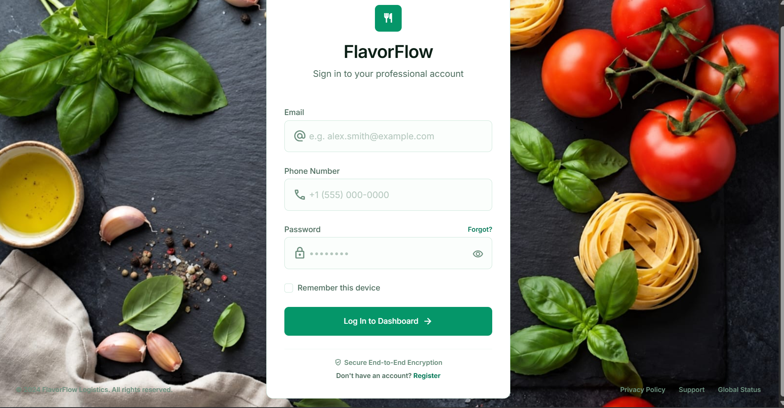
Figure: Login page
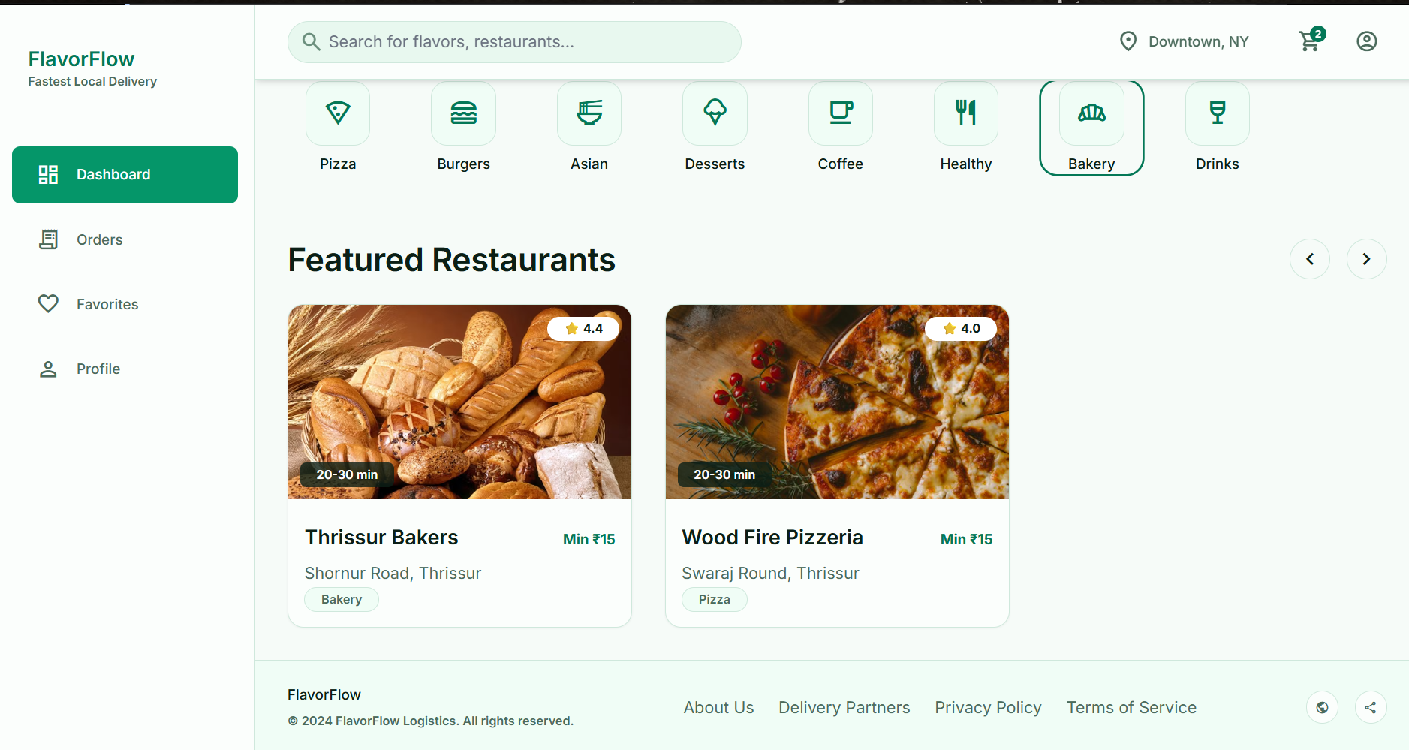
Figure: Dashboard with category filter
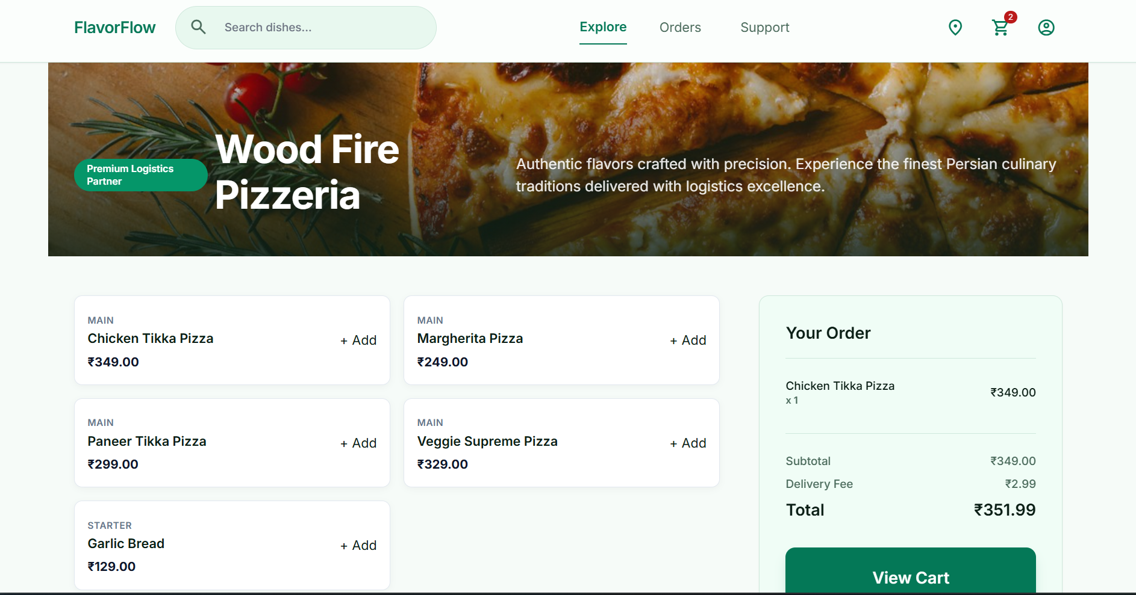
Figure: Restaurant menu and order box
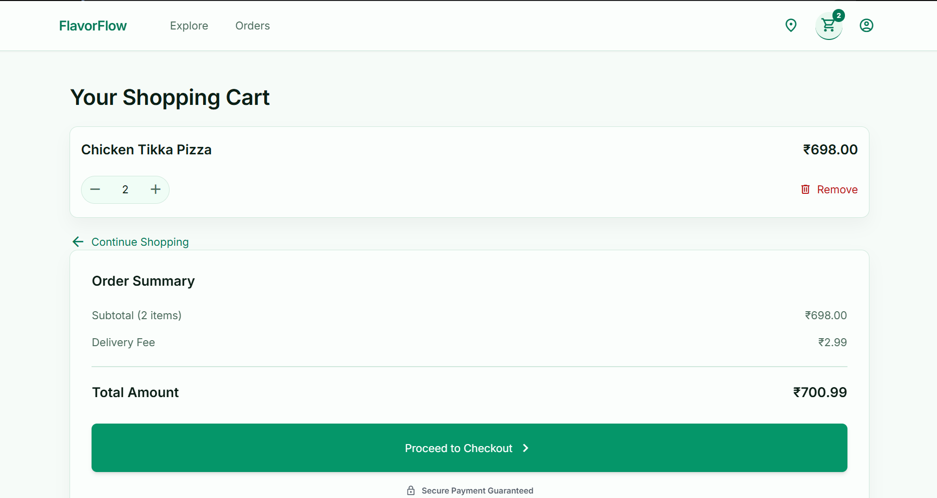
Figure: Cart and order summary
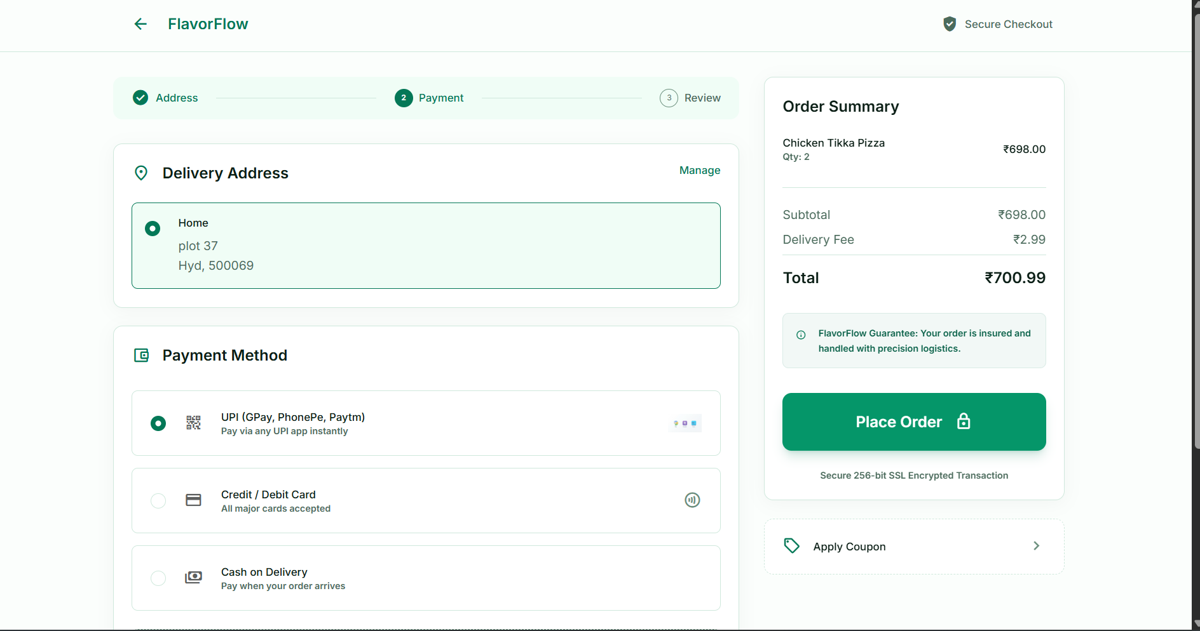
Figure: Checkout with address and payment method
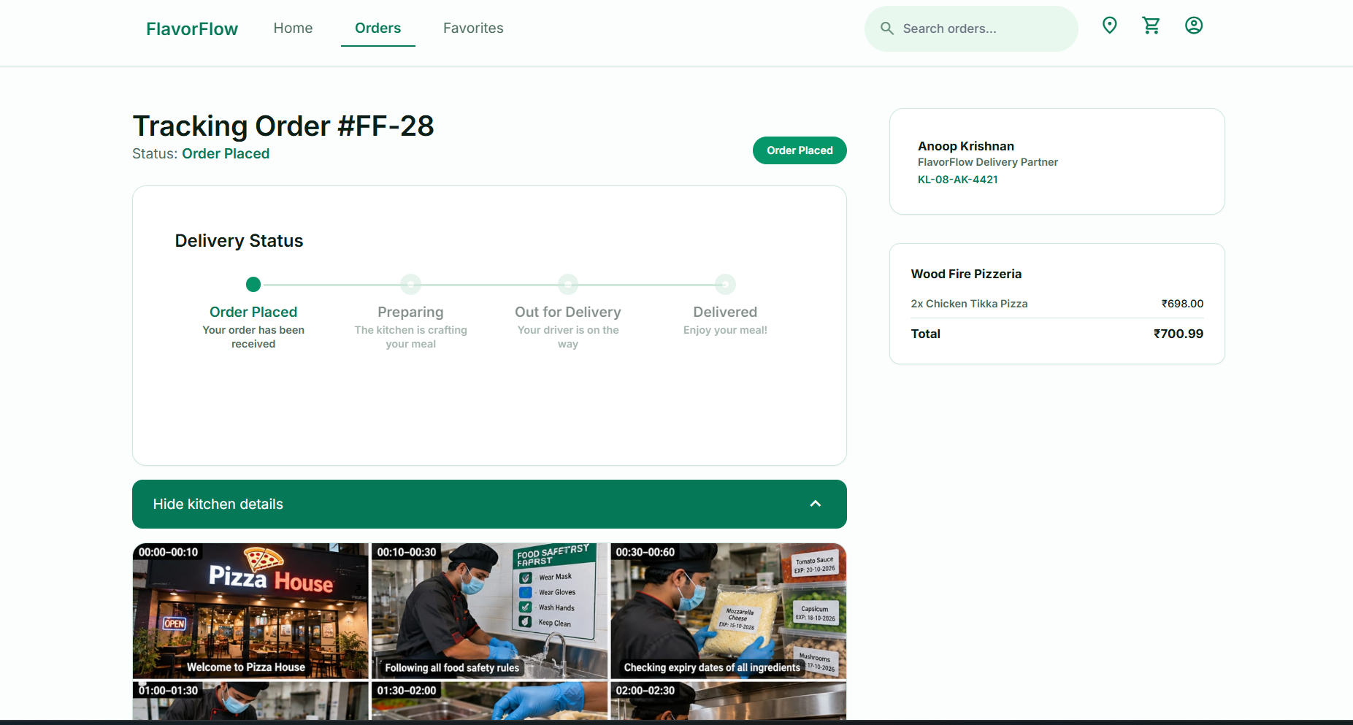
Figure: Order tracking timeline and kitchen panel
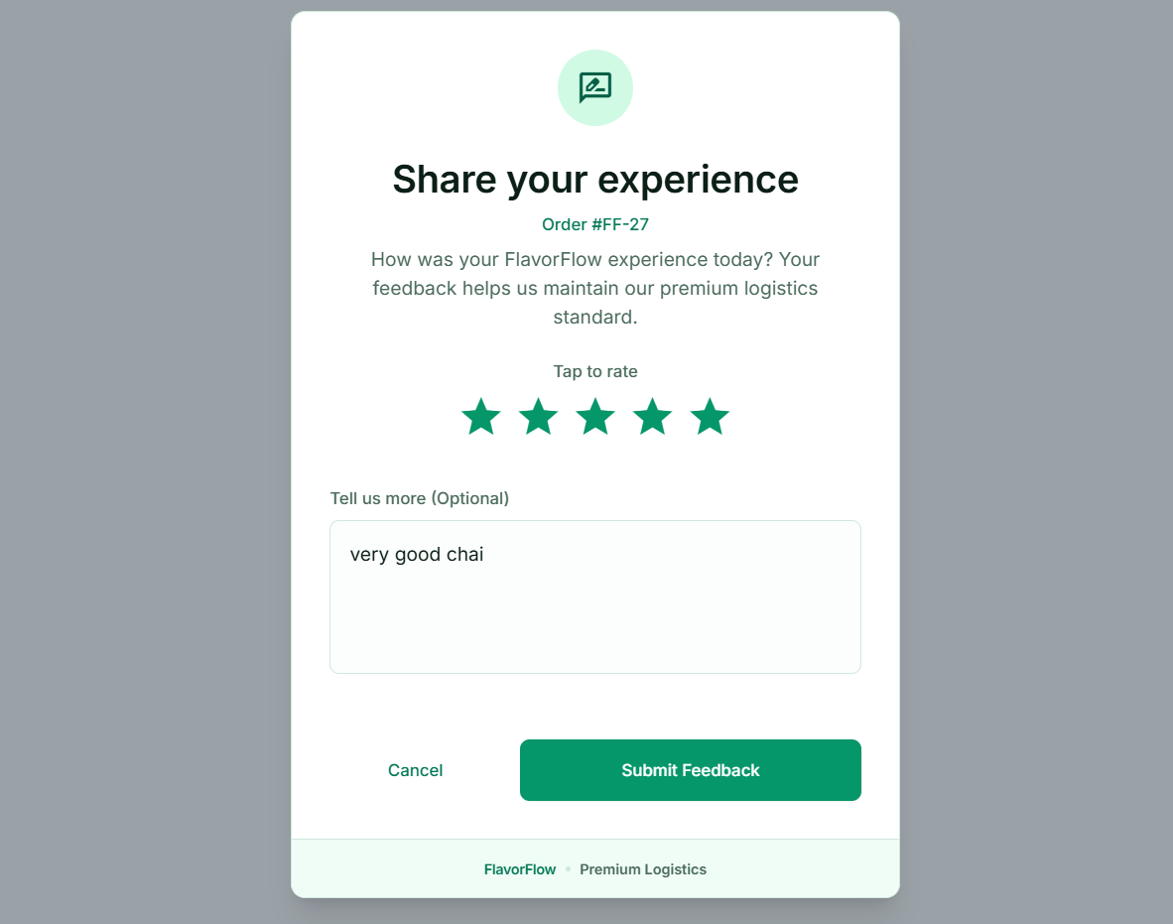
Figure: Feedback page

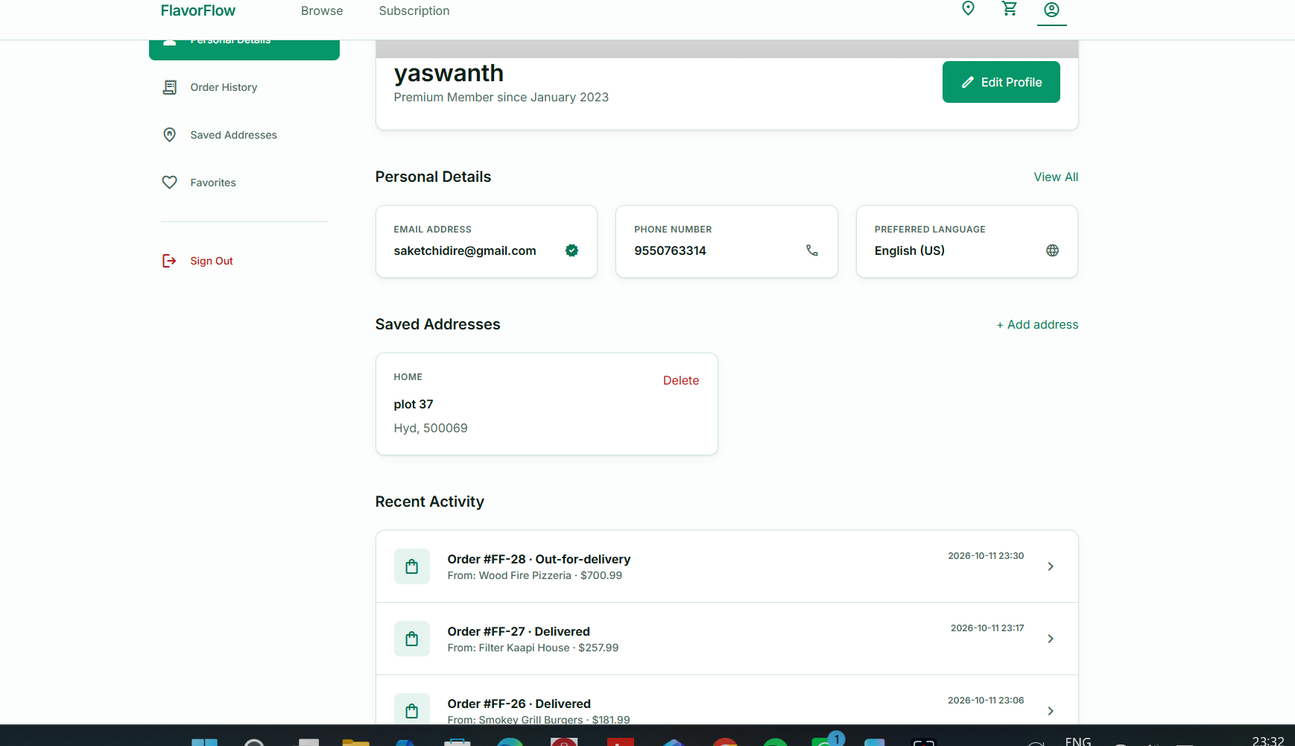
Figure: Profile with saved addresses

5. Database Design

5.1 Entities and Attributes
Entity (table) | Attributes | Primary key | Foreign keys
CUSTOMER | customer_id, name, email, phone, password, created_at | customer_id | -
ADDRESS | address_id, customer_id, street, city, pincode, address_type | address_id | customer_id to CUSTOMER
RESTAURANT | restaurant_id, name, location, cuisine_type, rating, created_at | restaurant_id | -
MENU_ITEM | item_id, restaurant_id, item_name, price, category, availability | item_id | restaurant_id to RESTAURANT
DELIVERY_AGENT | agent_id, name, phone, vehicle_no, availability_status, created_at | agent_id | -
CART | cart_id, customer_id, created_at | cart_id | customer_id to CUSTOMER (UNIQUE)
CART_ITEM | cart_id, item_id, quantity | (cart_id, item_id) | cart_id to CART; item_id to MENU_ITEM
ORDERS | order_id, customer_id, restaurant_id, agent_id, delivery_address_id, order_date, status, total_amount | order_id | customer_id, restaurant_id, agent_id, delivery_address_id to ADDRESS (ON DELETE SET NULL)
ORDER_ITEM | order_id, item_id, quantity, unit_price | (order_id, item_id) | order_id to ORDERS; item_id to MENU_ITEM
PAYMENT | payment_id, order_id, amount, method, status, payment_date | payment_id | order_id to ORDERS (UNIQUE)
FEEDBACK | feedback_id, order_id, customer_id, rating, comments, feedback_date | feedback_id | order_id to ORDERS (UNIQUE); customer_id to CUSTOMER

5.2 Relationships and Cardinalities
Relationship | Cardinality | Participation
CUSTOMER - ADDRESS | 1:N | Total on ADDRESS; partial on CUSTOMER
CUSTOMER - CART | 1:1 | Total on both sides
CUSTOMER - ORDERS | 1:N | Total on ORDERS
CUSTOMER - FEEDBACK | 1:N | Total on FEEDBACK
RESTAURANT - MENU_ITEM | 1:N | Total on MENU_ITEM
RESTAURANT - ORDERS | 1:N | Total on ORDERS
CART - MENU_ITEM (CART_ITEM) | M:N | Partial on both sides
ORDERS - MENU_ITEM (ORDER_ITEM) | M:N | Total on ORDERS
ORDERS - PAYMENT | 1:1 | Total on both sides
DELIVERY_AGENT - ORDERS | 1:N | Partial on both sides
ORDERS - FEEDBACK | 1:1 | Partial on both sides
ORDERS - ADDRESS | 1:N | Partial on both sides; ON DELETE SET NULL on the order reference

5.3 ER Diagram
The ER diagram shows the eleven entities above with their attributes, primary keys, and the relationships in Section 5.2. Draw it in a tool such as draw.io or Lucidchart and insert it here.
[Insert screenshot here: ER diagram of the FlavorFlow database]
Figure: ER diagram of the FlavorFlow database

5.4 Relational Schema
Converting the ER model follows the standard rules: each strong entity becomes a table, each 1:N relationship becomes a foreign key on the many side, and each M:N relationship becomes a bridge table whose key combines both foreign keys. The 1:1 relationships are enforced with UNIQUE foreign keys.
CUSTOMER(customer_id PK, name, email UNIQUE NOT NULL, phone, password, created_at)
ADDRESS(address_id PK, customer_id FK->CUSTOMER, street, city, pincode, address_type)
RESTAURANT(restaurant_id PK, name, location, cuisine_type, rating, created_at)
MENU_ITEM(item_id PK, restaurant_id FK->RESTAURANT, item_name, price, category, availability)
DELIVERY_AGENT(agent_id PK, name, phone, vehicle_no UNIQUE, availability_status, created_at)
CART(cart_id PK, customer_id FK->CUSTOMER UNIQUE, created_at)
CART_ITEM(cart_id PK,FK->CART, item_id PK,FK->MENU_ITEM, quantity CHECK>0)
ORDERS(order_id PK, customer_id FK, restaurant_id FK, agent_id FK NULL,
delivery_address_id FK->ADDRESS NULL, order_date, status, total_amount)
ORDER_ITEM(order_id PK,FK->ORDERS, item_id PK,FK->MENU_ITEM, quantity CHECK>0, unit_price)
PAYMENT(payment_id PK, order_id FK->ORDERS UNIQUE, amount, method, status, payment_date)
FEEDBACK(feedback_id PK, order_id FK->ORDERS UNIQUE, customer_id FK, rating CHECK 1..5, comments)

5.5 Constraints
• NOT NULL on essential attributes such as name, email, price and order status.
• UNIQUE on customer email, delivery agent vehicle number, one cart per customer, one payment per order and one feedback per order.
• CHECK on quantities (greater than zero) and feedback ratings (1 to 5).
• ON DELETE CASCADE on CART and CART_ITEM, so a removed customer leaves no orphaned cart rows.
• ON DELETE SET NULL on ORDERS.delivery_address_id, so deleting an address keeps the order and clears only its reference.
• Default values: status Placed, availability TRUE, rating 0, and current timestamps for creation dates.

5.6 Normalization and Functional Dependencies
To show how redundancy is removed, consider a flat receipt table that stores everything about an order in one row per item:
ORDER_DETAILS(order_id, order_date, customer_id, customer_name, customer_email,
restaurant_id, restaurant_name, restaurant_location, agent_id, agent_name, agent_phone,
item_id, item_name, item_price, quantity, payment_method, payment_amount)
Functional dependencies observed in this table:
• order_id -> order_date, customer_id, restaurant_id, agent_id, payment_method, payment_amount
• customer_id -> customer_name, customer_email
• restaurant_id -> restaurant_name, restaurant_location
• agent_id -> agent_name, agent_phone
• item_id -> item_name, item_price
• (order_id, item_id) -> quantity
Normalization steps:
• Unnormalised form to 1NF: the repeating item group is flattened so that one row holds one (order, item) pair.
• The candidate key is (order_id, item_id). The closure of this key covers all 17 attributes, and neither attribute alone determines the others.
• 1NF to 2NF: partial dependencies are removed. Order details depend on order_id only, and item details depend on item_id only. They are split into ORDER_INFO, ITEM_INFO and ORDER_LINE.
• 2NF to 3NF: transitive dependencies are removed from ORDER_INFO. Customer, restaurant and agent details move into their own tables, keyed on their own IDs.
• 3NF to BCNF: each remaining table has a single candidate key and every determinant is a superkey, so no further decomposition is needed.
The final relations correspond to the schema in Section 5.4. Normalization prevents three anomalies. An update anomaly is avoided because correcting a restaurant name changes one row, not every order. An insertion anomaly is avoided because a restaurant or menu item can exist before any order. A deletion anomaly is avoided because deleting the last order for a restaurant does not delete the restaurant.

5.7 Design Decision: Delivery Fee in the Total
The delivery fee of ₹2.99 is added to ORDERS.total_amount and to PAYMENT.amount, so the stored total equals the amount the customer pays. The fee is a fixed charge rather than a derived attribute of the order items, so this is a deliberate departure from the pure item-sum rule in the original design. It is documented here so the change is traceable.
[Insert screenshot here: Database tables in pgAdmin (food_delivery)]
Figure: Database tables in pgAdmin (food_delivery)

6. Database Selection & Justification
The project uses PostgreSQL 18 as its DBMS. PostgreSQL was chosen for the following reasons.
Factor | Why PostgreSQL suits this project
Data integrity | Full support for primary, foreign and unique keys, CHECK constraints, and ON DELETE rules. These are used heavily in the design.
Transactions | ACID transactions with rollback. The checkout process depends on this to save an order atomically.
Concurrency | Row-level locking with FOR UPDATE SKIP LOCKED lets the dispatcher assign drivers safely when requests overlap.
SQL features | SERIAL keys, RETURNING clauses, and INSERT ... ON CONFLICT DO UPDATE, which implements add-to-cart in one statement.
Error reporting | Constraint violations return standard SQLSTATE codes, such as 23505 for duplicate keys, which the application uses to show clear messages.
Cost | Free and open source, with no licence cost for a university project or a later deployment.
Tooling and support | pgAdmin provides a visual interface for designing and querying tables. The JDBC driver is mature and available through Maven.
Scalability | Handles large tables with indexes, which the schema defines on frequently searched columns such as customer email and order status.
Portability | Runs on Windows, Linux and macOS, and most cloud providers offer it as a managed service.

Compared with MySQL, PostgreSQL offers stronger standards compliance and richer constraint support. Compared with Oracle, it avoids licence costs and works without special hardware. The choice fits the project because the core requirements are correctness and transactional safety rather than specialized enterprise features.

7. Implementation

7.1 Architecture
The application is a three-tier system. The presentation tier is a set of HTML pages styled with Tailwind CSS and driven by JavaScript. The application tier is a set of Java servlets running on Apache Tomcat 10.1, packaged as one WAR file and built with Maven. The data tier is PostgreSQL, accessed through JDBC. Each servlet corresponds to one feature and one URL, and returns JSON. Two helper classes support the servlets: Auth reads the logged-in customer from the session, and Dispatcher advances order stages and assigns agents.

7.2 Database Creation
The database is created with CREATE DATABASE food_delivery. The schema is applied from a single SQL script containing the eleven CREATE TABLE statements, the indexes on frequently searched columns, and sample data. Tables are created in dependency order so that every foreign key refers to an existing table.
CREATE TABLE CART_ITEM (
cart_id INT NOT NULL,
item_id INT NOT NULL,
quantity INT NOT NULL DEFAULT 1 CHECK (quantity > 0),
PRIMARY KEY (cart_id, item_id),
FOREIGN KEY (cart_id) REFERENCES CART(cart_id) ON DELETE CASCADE,
FOREIGN KEY (item_id) REFERENCES MENU_ITEM(item_id)
);
Later, the delivery address feature added a reference from orders to addresses:
ALTER TABLE ORDERS
ADD COLUMN delivery_address_id INT
REFERENCES ADDRESS(address_id) ON DELETE SET NULL;

7.3 Sample Data
The sample data includes customers, eight Thrissur restaurants with menus, delivery agents, and carts. Each restaurant has a menu for pizza, burgers, Asian food, desserts, coffee, healthy food, bakery and drinks. The restaurant rows are inserted as follows:
INSERT INTO restaurant (name, location, cuisine_type, rating) VALUES
('Wood Fire Pizzeria', 'Swaraj Round, Thrissur', 'Pizza', 4.5),
('Smokey Grill Burgers', 'Punkunnam, Thrissur', 'Burgers', 4.4),
('Dragon Wok', 'Chembukkavu, Thrissur', 'Asian', 4.3),
('Sweet Affair Desserts', 'Round South, Thrissur', 'Desserts', 4.6),
('Filter Kaapi House', 'Ayyanthole, Thrissur', 'Coffee', 4.7),
('Green Bowl Kitchen', 'Kuttanellur, Thrissur', 'Healthy', 4.2),
('Thrissur Bakers', 'Shornur Road, Thrissur', 'Bakery', 4.4),
('Juice Junction', 'Koorkenchery, Thrissur', 'Drinks', 4.5);

7.4 Key SQL Queries
Query 1: list restaurants ordered by rating (join-free, used on the dashboard).
SELECT restaurant_id, name, location, cuisine_type, rating
FROM RESTAURANT
ORDER BY rating DESC;
Query 2: menu of one restaurant, using a prepared statement with a parameter.
SELECT item_id, item_name, price, category
FROM MENU_ITEM
WHERE restaurant_id = ? AND availability = TRUE
ORDER BY category, item_name;
Query 3: add an item to the cart, or increase its quantity if it is already there.
INSERT INTO CART_ITEM (cart_id, item_id, quantity) VALUES (?, ?, ?)
ON CONFLICT (cart_id, item_id)
DO UPDATE SET quantity = CART_ITEM.quantity + EXCLUDED.quantity;
Query 4: cart contents with the item names (join across three tables).
SELECT m.item_id, m.item_name, m.price, ci.quantity
FROM CART c
JOIN CART_ITEM ci ON ci.cart_id = c.cart_id
JOIN MENU_ITEM m ON m.item_id = ci.item_id
WHERE c.customer_id = ?
ORDER BY m.item_name;
Query 5: order tracking, combining orders, restaurants and delivery agents.
SELECT o.order_id, o.order_date, o.status, o.total_amount,
r.name AS restaurant_name, a.name AS agent_name, a.vehicle_no
FROM ORDERS o
JOIN RESTAURANT r ON r.restaurant_id = o.restaurant_id
LEFT JOIN DELIVERY_AGENT a ON a.agent_id = o.agent_id
WHERE o.order_id = ? AND o.customer_id = ?;
Query 6: restaurant rating recalculated from feedback after a new review.
UPDATE RESTAURANT SET rating = (
SELECT ROUND(AVG(f.rating), 1)
FROM FEEDBACK f JOIN ORDERS o ON o.order_id = f.order_id
WHERE o.restaurant_id = RESTAURANT.restaurant_id)
WHERE restaurant_id = (SELECT restaurant_id FROM ORDERS WHERE order_id = ?);
Query 7: free delivery agent selection, with row locking to prevent double assignment.
SELECT agent_id FROM DELIVERY_AGENT
WHERE availability_status = 'Free'
ORDER BY agent_id
LIMIT 1 FOR UPDATE SKIP LOCKED;

7.5 Checkout Transaction
Checkout is the most important transaction in the system. The steps below all run inside one database transaction with auto-commit turned off:
• Find the cart for the logged-in customer and read its rows with current menu prices.
• Reject the request if the cart is empty or if its items come from more than one restaurant.
• Insert the order with the total, delivery fee included, and the chosen delivery address.
• Copy each cart row into ORDER_ITEM, storing the unit price at the time of ordering.
• Insert the payment record with status Completed.
• Delete the cart rows, then call the dispatcher and commit.
If any step throws an error, the transaction is rolled back and nothing is saved. This is the mechanism that guarantees that an order, its items, its payment and the cleared cart always agree.

7.6 CRUD Operations
Operation | Feature | SQL operation | Servlet
Create | Register customer and cart | INSERT CUSTOMER, INSERT CART | RegisterServlet
Create | Add to cart, save address, save feedback, place order | INSERT CART_ITEM, ADDRESS, FEEDBACK, ORDERS, ORDER_ITEM, PAYMENT | CartServlet, AddressServlet, FeedbackServlet, CheckoutServlet
Read | Restaurants, menus, cart, tracking, profile, orders | SELECT with joins | RestaurantServlet, MenuServlet, CartServlet, TrackingServlet, CustomerServlet
Update | Change quantity, edit profile, dispatch, rating | UPDATE CART_ITEM, CUSTOMER, ORDERS, DELIVERY_AGENT, RESTAURANT | CartServlet, CustomerServlet, Dispatcher, FeedbackServlet
Delete | Remove cart item, delete address | DELETE CART_ITEM, ADDRESS | CartServlet, AddressServlet

7.7 Dispatcher
The dispatcher runs on each request that reads or changes orders. It advances each order's status according to its age, marks each delivery agent busy or free based on their active orders, and assigns the oldest unassigned order to a free agent. The thresholds are one minute for Preparing, three minutes for Out-for-delivery and six minutes for Delivered, and they are set in one place in the code so they can be changed for a demonstration.

7.8 Security Measures
• Every SQL statement with user input uses a PreparedStatement with bound parameters.
• Each servlet that handles customer data checks the session and returns 401 when no customer is logged in.
• Every query for a customer also filters by customer_id, so one customer cannot read or change another customer's data.
• Input is checked in the servlet (required fields, numeric IDs, rating range, email format, 10-digit phone) before the database is touched.
Limitation: passwords are stored as plain text, as in the sample data. A production system would store a salted hash, such as bcrypt. This is discussed in Chapters 10 and 11.

8. Testing & Validation
Each test case lists the input, the expected output, the actual output observed during testing, and the result. The actual output and result columns should be completed by running each test on the final version of the system.

8.1 Functional Test Cases
TC | Test | Input | Expected output | Actual output | Result
TC01 | Register new customer | Name, unique email, 10-digit phone, 6+ character password | Account and cart created; user logged in | [enter] | [Pass/Fail]
TC02 | Login with correct details | Email, phone and password of an existing customer | Session created; redirect to dashboard | [enter] | [Pass/Fail]
TC03 | Login with wrong password | Correct email and phone, wrong password | Error: incorrect details; no session | [enter] | [Pass/Fail]
TC04 | Add item to cart | item_id of a menu item, quantity 1 | One CART_ITEM row with quantity 1; badge updated | [enter] | [Pass/Fail]
TC05 | Add same item twice | Same item_id added twice | Single row; quantity 2 | [enter] | [Pass/Fail]
TC06 | Set quantity to zero | Quantity 0 for a cart item | Row deleted; totals updated | [enter] | [Pass/Fail]
TC07 | Checkout with empty cart | Place order with no items | Error: cart is empty; no order created | [enter] | [Pass/Fail]
TC08 | Checkout with items from two restaurants | Cart containing a pizza and a dessert | Rejected; no order, order items or payment saved | [enter] | [Pass/Fail]
TC09 | Valid checkout | Cart with items, saved address, UPI | Order saved with total including ₹2.99; items copied; payment Completed; cart emptied | [enter] | [Pass/Fail]
TC10 | Feedback before delivery | Feedback for an order with status Placed | Rejected: available after delivery | [enter] | [Pass/Fail]
TC11 | Feedback after delivery | Rating 4 with comment on a Delivered order | Feedback saved; restaurant rating recalculated | [enter] | [Pass/Fail]
TC12 | Second feedback for same order | Another rating for the same order | Rejected: already reviewed | [enter] | [Pass/Fail]
TC13 | Address deletion for past order | Delete an address used by an existing order | Address removed; order kept with delivery_address_id NULL | [enter] | [Pass/Fail]
TC14 | Dispatcher assignment | Three active orders, two free agents | Two oldest orders assigned; third waits without an agent | [enter] | [Pass/Fail]
TC15 | Dispatcher progression | Order placed more than six minutes ago | Status Delivered; agent returned to Free | [enter] | [Pass/Fail]
TC16 | Access without login | Call api/cart with no session | HTTP 401: Please log in | [enter] | [Pass/Fail]
TC17 | Edit profile with invalid phone | Phone with 9 digits | Rejected: phone must be 10 digits | [enter] | [Pass/Fail]

8.2 Data Integrity and Constraint Validation
TC | Constraint tested | Action | Expected database response | Actual output | Result
DI1 | UNIQUE on customer email | Insert a second customer with an existing email | Error SQLSTATE 23505 | [enter] | [Pass/Fail]
DI2 | CHECK on rating | Insert feedback with rating 6 | Error: check constraint violated | [enter] | [Pass/Fail]
DI3 | CHECK on quantity | Insert CART_ITEM with quantity -1 | Error: check constraint violated | [enter] | [Pass/Fail]
DI4 | Primary key on CART_ITEM | Insert the same (cart_id, item_id) twice | Second insert rejected or merged by ON CONFLICT | [enter] | [Pass/Fail]
DI5 | Foreign key on MENU_ITEM | Insert a menu item for restaurant_id 999 | Error: foreign key violated | [enter] | [Pass/Fail]
DI6 | UNIQUE on PAYMENT.order_id | Insert a second payment for the same order | Error SQLSTATE 23505 | [enter] | [Pass/Fail]
DI7 | ON DELETE CASCADE | Delete a customer with a cart | Cart and cart items removed | [enter] | [Pass/Fail]
DI8 | ON DELETE SET NULL | Delete an address used by an order | Order remains; reference set to NULL | [enter] | [Pass/Fail]
DI9 | NOT NULL on ORDERS.status | Insert an order with a NULL status | Error: null value violates constraint | [enter] | [Pass/Fail]

8.3 Validation Summary
The test results show whether each business rule is enforced at the right level. Rules that depend on several rows, such as the single-restaurant rule and the one-review-per-order rule, are checked by the servlet and protected by the database. Rules that depend on a single value, such as rating range and quantity, are enforced by CHECK constraints.

9. Results & Screenshots
The system was deployed on Apache Tomcat 10.1 and tested in a web browser against the PostgreSQL database. The screenshots below show the main functions. Each one has a caption and a short explanation that should be written in your own words after the screenshot is taken.

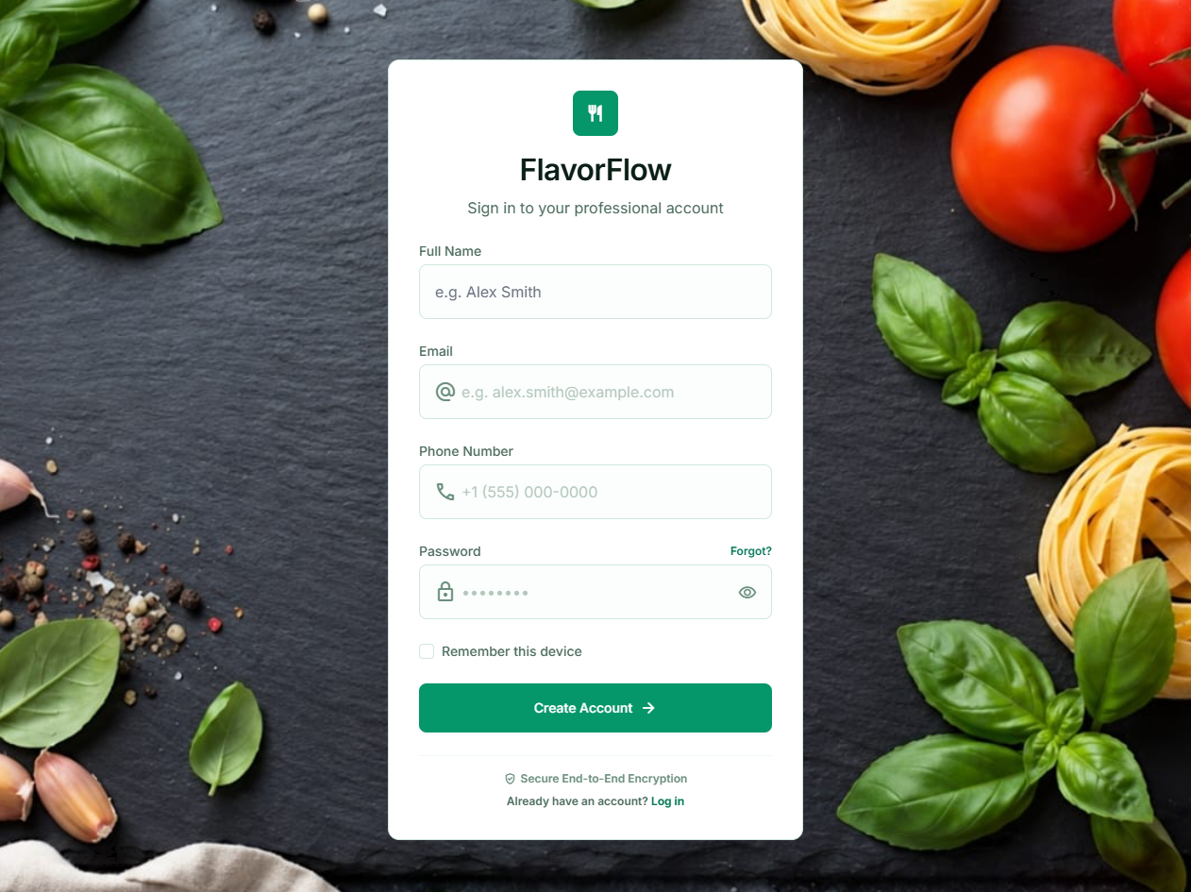
Figure: Registration form creating a new account
Explanation: New customer and cart creation.
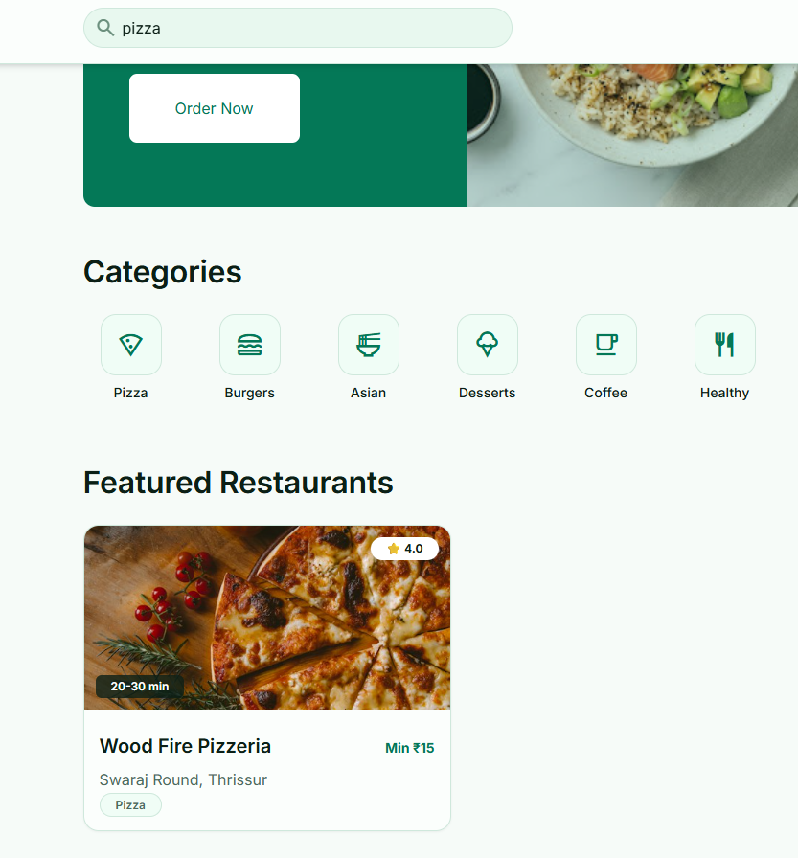
Figure: Dashboard with restaurant cards and search
Explanation: Restaurant listing from the RESTAURANT table.
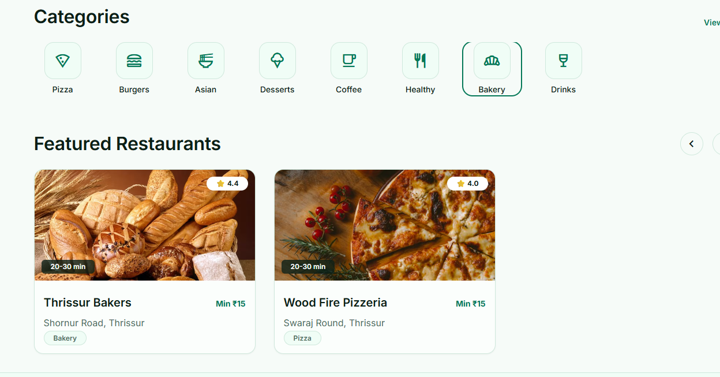
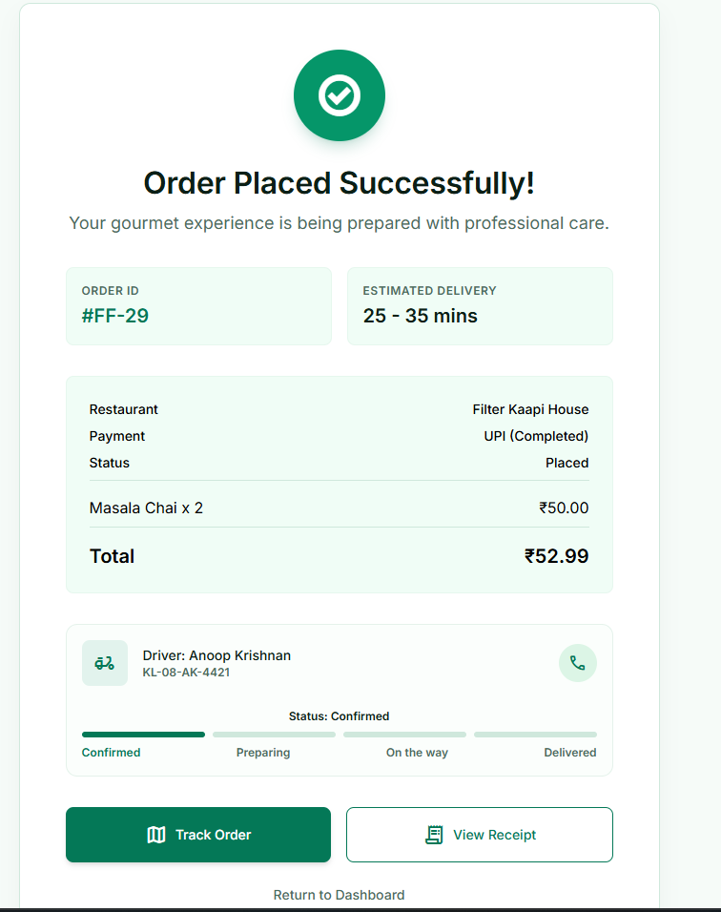

10. Challenges Faced & Solutions
Challenge | Solution
Tomcat 9 and Tomcat 10 use different servlet packages (javax and jakarta). | The project was aligned with Tomcat 10.1 and the jakarta.servlet API. The servlet and dependency versions in pom.xml were matched to that version.
Deploying a WAR file on Windows, including path and copy issues. | A fixed sequence of commands was used: build with Maven, copy the WAR to webapps, and restart the Tomcat service. Old deployments were removed before redeploying.
Converting a Stitch-exported design into working servlet-backed pages. | Each exported screen was split into an HTML page, with JavaScript added to fetch data and build the content. Repeated sections were replaced by containers filled from the API.
Keeping an order consistent when a step fails midway through checkout. | All checkout steps were placed in one transaction with auto-commit turned off. Any error triggers a rollback, which was verified with the failure tests in Chapter 8.
Two requests could assign the same delivery agent at the same time. | Agent selection uses SELECT ... FOR UPDATE SKIP LOCKED, so a locked row is skipped by the other request.
Menu prices changing after an order was placed. | Each order item stores its unit price at the time of ordering, so past orders keep their original amounts.
Deleting an address that was used by past orders. | The foreign key uses ON DELETE SET NULL, so the order is kept and only the address link is cleared.
A cart must hold items from one restaurant only. | The checkout servlet checks the restaurants of all cart items and rejects a mixed cart with a clear message.
Category filter needed to match restaurants by menu items, not only by cuisine label. | The page loads each restaurant's menu and matches item names and categories against keyword rules for each category.
Passwords need to be stored securely, but the project uses plain text. | Recorded as a known limitation. The recommended fix is to store a salted hash and verify it at login.
Database credentials appearing in source code. | Identified as a risk before sharing the project. The recommended fix is a single database configuration class that reads credentials from environment variables.

11. Conclusion & Future Enhancements

11.1 Conclusion
FlavorFlow meets its objectives. It models the food delivery domain as a normalized relational database with eleven tables and enforces its business rules with keys, constraints and transactions. The web interface covers registration, browsing, cart management, checkout, tracking, feedback and profile management, and every function is backed by a SQL operation. The test cases in Chapter 8 show that the constraints and the transaction behave as designed. The project shows how a relational database supports a real transactional application, from the first ER diagram to the final screen.

11.2 Future Enhancements
• Real payment gateway integration for UPI and card payments, with payment status updated from the gateway.
• Hashed passwords with salting, and a proper password reset flow.
• Store the delivery fee as a separate column, and show it as its own line on the confirmation page.
• Live map tracking using driver location data and a map service.
• Restaurant and delivery agent dashboards, so owners can manage menus and agents can accept orders.
• Mobile application that uses the same servlet APIs.
• Cloud deployment with a managed PostgreSQL service and HTTPS.
• Analytics pages for orders by restaurant, popular items and average delivery time.
• Scheduled dispatching instead of checks on each request, and automated tests for each servlet.

References
Elmasri, R., & Navathe, S. B. Fundamentals of Database Systems (7th ed.). Pearson.
Silberschatz, A., Korth, H. F., & Sudarshan, S. Database System Concepts (7th ed.). McGraw-Hill.
PostgreSQL Global Development Group. PostgreSQL 18 Documentation. https://www.postgresql.org/docs/
PostgreSQL JDBC Driver (org.postgresql:postgresql 42.7.4). https://jdbc.postgresql.org/
Apache Software Foundation. Apache Tomcat 10.1 Documentation. https://tomcat.apache.org/
Eclipse Foundation. Jakarta Servlet 6.0 Specification. https://jakarta.ee/specifications/servlet/
Google. Gson Library (com.google.code.gson:gson 2.11.0). https://github.com/google/gson
Apache Software Foundation. Apache Maven Documentation. https://maven.apache.org/
Tailwind Labs. Tailwind CSS Documentation. https://tailwindcss.com/docs
Google. Stitch: UI design tool used for the screen designs. https://stitch.withgoogle.com/
Google Fonts. Inter typeface and Material Symbols. https://fonts.google.com/
Unsplash. Free photographs used for restaurant images. https://unsplash.com/
Mozilla Developer Network. Fetch API documentation. https://developer.mozilla.org/en-US/docs/Web/API/Fetch_API

